What am I hoping you will take away from the following backstory?

- Fingilótë and Melody come from a unique family tree and are direct descendants of amazing Elves, Maia, and Men.

- Thingol, the first Teleri Elve and his wife, Melian, a Maia.
- Their daughter Luthian and her husband Beren.
- Their son Dior and his wife Nimloth, niece of Celeborn.

- Fingilote and Melody are the rightful heirs of the realm in Doriath and the Capital, Menegroth (The Thousand Caves). Which took about 1,500 years to originally build and is currently covered by the sea.
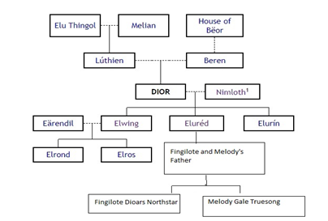

Fingilote and Melody’s Backstory:
“So how did an elven gal find herself up growing up in Lothlorien? I am not sure! I am truly just a common girl that enjoys making people smile from my song.
My grandfather, Gwinion, was my biggest fan! He loved to listen to me sing and play my lute. He was the one always encouraging me to play for others. My great uncle, Edechon use to say, I had talent from an age from long ago. I am not sure about that! What as am sure of, is how alive I feel when I create music. Most times, I just relax and let nature take over my voice.
Once when I was young, I was alone singing in the forest. I closed my eyes and became lost in my song. When suddenly I realized more than a dozen nightingales had joined in with my singing! How did the nightingales know instinctively what I was going to sing next? Still to this day, it is not uncommon for nightingales to be seen flying around me when I am singing. This makes me smile.
The lady of the woods, Galadriel, once came to one of my performances. After she just smiled and said, she would be so proud. Excuse me? I replied. Yet she would say no more.
My next biggest fan is my twin brother. I miss him. He has been away for many years now.
He traveled with my grandfather, Gwinion and his twin brother, Edechon, to the North. The Grey Havens I believe they called it. My brother insisted he travel along with them for protection. That is so typical of my, brother, always wanting to protect others. But this time I agreed! But he said he would return as soon my grandfather and great uncle were safely on the ship, sailing back to the undying lands.
He simply has been away too long! My plans are to leave tomorrow, following their path north to find what happened to my brother.
Do not worry about me! I have it all planned out. I even know which taverns and inns along the way where I will be staying. If I am lucky, they will have entertainment! Learning lore from others is my other passion. All my travels are going well, and I am just a few days away from reaching the Grey Havens, I am staying at an Inn called “The Prancing Pony” in a small, out of the way town called Bree.
When the entertainment started, I smiled. The old singer seemed to have a way of spinning tales. Then someone yelled from the crowd, “Spin us the tale again about the lost sons of Nimloth! For it has been ages since you have told that tale. And you better tell it again now before the cobwebs completely fill your brain!” Those of us in the inn that night, laughed on hearing this.
The old elven bard smiled and said, “My memory is a good as ever. But you better fill you glasses again. For this tell is long.” Then he shouted, “Butterman, a large flask of wine please!”
My world that night changed forever … for when he started to speak, it seemed he was speaking directly to me.
“Come closer to the fire, my friends, so the flames may warm your traveling cloaks. Close your eyes for just a moment and travel back in time with me. Now, in middle-earth, when the lands were still young, Elwe (Thingol), was the first Teleri Elves in existence. While he was traveling through the Nan Elmoth Forest, he met Melian (a Maia). Upon first gazing into each other’s eyes, they were set in a trance for years, and I mean years!
“So they stood thus while long years were measured by the wheeling stars above them; and the trees of the Nan Elmoth grew tall and dark before they spoke any word.”
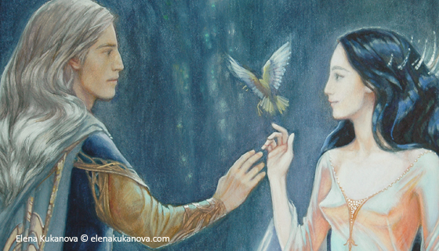
Melian was described as immeasurably beautiful, the wisest of her kin, and none of her kin one was more skilled in song of enchantment than her. It is said, it was Melian who taught the nightingales how to sing.
Cirdan (the shipwright) was related to Thingol and was in Middle Earth when Thingol went missing. Cirdan waited and searched for Thingol the longest, out of love and allegiant to Thingol. Yet, Thingol was lost in time, starring into Melian’s eyes.
In their own time, Thingol and Melian married, and they established their realm in Doriath and created their Capital, Menegroth. Which was also called The Thousand Caves. ~1,500 years to build.

Later, around the 50th year of the First Age, Galadriel and her older brother Finrod were guests in King Thingol’s Halls. In these halls is where Galadriel meet Celeborn and they fell in love. From Melian, Galadriel learned how to make Lembas bread, which Melian had learned from Yavanna, Queen of Nature.
Thingol and Melian had a daughter and name her Luthien. When the man Beren, son of Barahir, from the royal house of Beor crossed into Doraith, through the forest of Dungortheb, he saw Luthien for the first time and they fell in love.
When Beren asked, Thingol refused to give his daughter’s hand in marriage. He said that he would allow the marriage to take place only if Beren brought back a Silmaril from the Crown of Morgoth. The task was intended to be impossible! But Beren, Lúthien, and Finrod (Galadriel brother), with the aid of Huan, the Great Hound, braved many perils and retrieved a Silmaril from the crown of Morgoth! This is how a Silmaril came into Thingol’s procession. Thingol also came to poses the neckless Nauglamir, made by the dwarves for Finrod. Thingol invited the great Dwarven craftsman to combine the neckless and the Silmaril together.
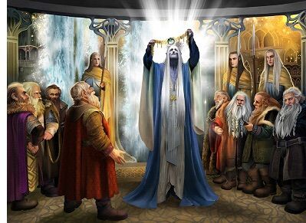
This piece is considered the most beautiful work of art from the First Age.
After seeing its beauty, the dwarves demanded the neckless for their own, yet Thingol refused! Thingol devised a plan to send the dwarves away without any payment. This of course resulted in mortal conflict, which eventually resulted in Thingol’s own death. And then revenge, upon revenge, between the dwarfs and the elves is why each respectively have such a distrust toward each other still to today.
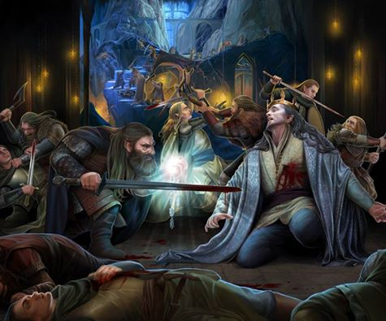
After Thingol’s death, his wife Melian decided to leave middle-earth and return to Aman. She would meet Cirdan at Mithlond, the Grey Havens. After she left, the protection from the “Girdle of Melian” stopped. The Kingdom of Doriath was now exposed, without the favor and protection of Melian.
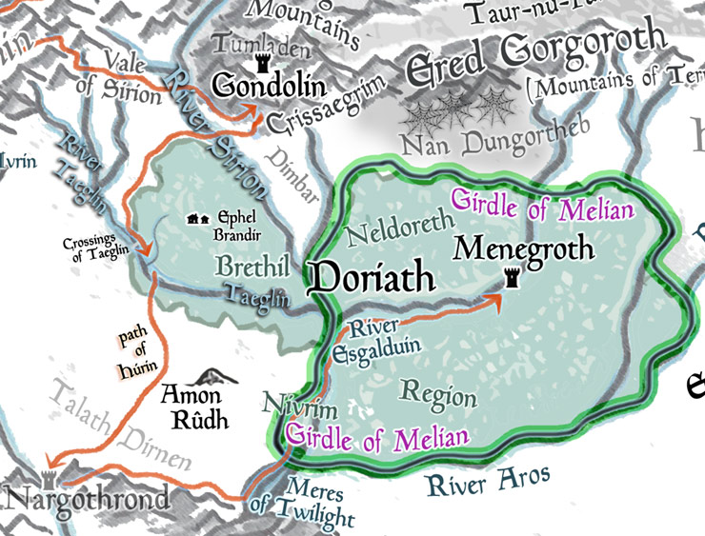
The tale of Lúthien and Beren is beautiful and long in song, but for this tale you need only to know, that Lúthien and Beren had a son and named him Dior, Thingol's eventual heir. After a time, Dior became the Lord of Doriath and, lord of the neckless, Nauglamir, on which one of the three Silmaril hung.
By many accounts, Dior was one of the fairest beings to ever live. For in him flowed the blood of men, of elves, and of the Ainur. Through his descendants, the blood of Beren and of Lúthien was preserved among the Eldar and the Edain.
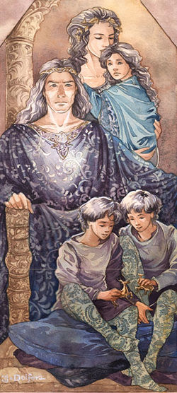

Dior married Nimloth, niece to Celeborn. Together, they had three children Elured, Elurin (twin sons), and Elwing (the future mother to Elrond and Elros).

“And now we come to the story ask for this evening,” said the old storyteller.

When the seven sons of Feanor learnt a Silmaril was in Doriath, they attacked Dior without mercy! Filling an oath, they made long ago to do anything to recover the stolen Silmarils. (see Oath of Feanor)
Yet, Dior was mighty and slew three (3) of sons alone: (1) Celegorm, (2) Caranthir, and (3) Curufin. Sadly, Dior also died in this senseless fight.
Feanor’s other sons, still loyal to their twisted oath, ruthlessly killed his wife Nimloth.
Next, Maedhros, the oldest son of Feanor, found the twin sons hiding. He took the twins, Elured and Elurin, into the forest and left them there to starve. The twins were only seven years old at the time.
Only their Dior’s daughter, Elwing, barely escaped with the Silmaril neckless.
Maedhros, sometime later repented and went searching for the twins in the forest. But no trace of the boys could be found. In the history of middle earth, no one knows what became of the twins.

This event is known as the second kin slaying and after which, the land of Dorthiath was abandoned.
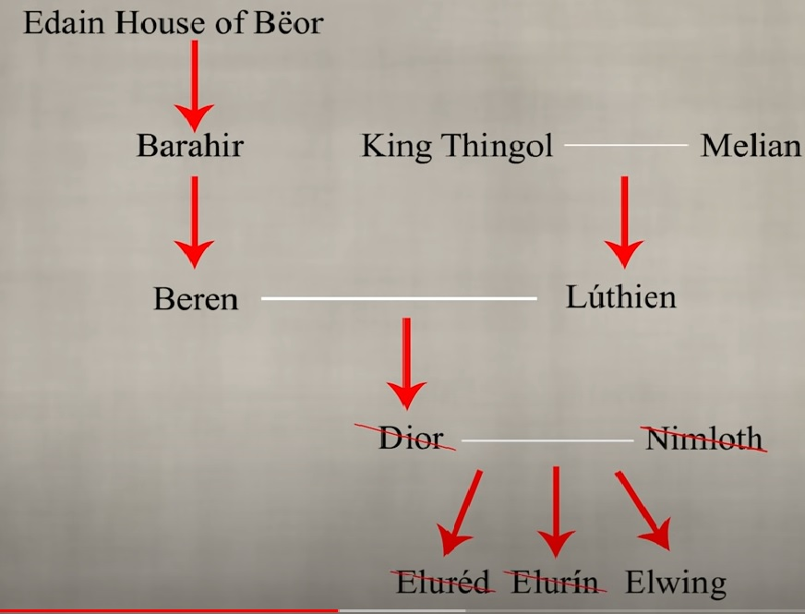

http://tolkiengateway.net/wiki/Elur%C3%A9d (if you wished for more information on killing)
“Eaten by wolves!” shouted a dwarf. “I say orcs had a feast on young elven meat that night!” shouted someone else. “No one can survive in that forest overnight, especially two young children!”
And the old storyteller repeated one last time … “In the history of middle earth, no one knows what became of the twins.”

The crowd clapped and the old elven singer stood and took a deep bow.
I was standing on my feet, clapping, and smiling. This was a true artist! Here was someone that knows how to entertain with lore and make other smile with song! “Well done my lord, you have a gift!”

Then he looked directly into my eyes and paused for a long moment, as if he were caught off guard.
He took a long drink from his flask of wine and started to speak again, but this time so softly that only my ears could hear. As the room had long since found their own drink more appealing than stories.
Never had he told this version of the story, but tonight he did.
“In the history of middle earth, no one knows what became of the twins. They were surely eaten by wolves.
Yet long, long, long ago, there was once a night when a scouting party of Celeborn came upon two young elven boys alone in the forest, and we were surprised. Yes, I was there to see with my own eyes.
Instead of crying or sulking in despair, the twin boys had made a hut in the trees for shelter and spears for weapons. And both boys, of seven years old, had an uncanny resemblance to their leader, Celeborn.
Gladriel upon hearing of the twins, demanded that they be brought to her. Her first action was to give the boys new names. Gwinion (new son) and Edechon (new brother) they shall be called. And no one knew why, but the names of Elured and Elurin were never again to be spoken in the land of Lothlorien.”
“My Grandfather and his brother!” Melody thought to herself and she was clearly shaken.
Again, he starred deep into my eyes and his gaze pierced my soul.
Gladriel still considered Melian, the twin’s great grandmother, her dear friend. They also were the children of her husband’s (Celeborn) niece, and the neckless that was causing all the trouble was originally made for Gladriel’s brother, Finrod!
Then he seemed to speak only with his eyes, not moving his lips, yet in my mind I clearly heard him say.
“It is said, it was Melian who taught the nightingales how to sing.”
When I awoke the next morning, my mind was confused. Quickly I packed my bags and headed onward toward my brother. Now I desperately wanted to tell him what I had heard last night to get his thoughts. He had no trouble in telling me if one of my ideas were crazy or if I was going insane!
The next few days were easy and the distance to the Grey Havens went by quickly. When I reached the shores, I instantly saw my brother in a distance.

“Fin! You big eared elf! Fin, it is your sister coming to rescue you!” Shout Melody
“Melody, what in the world are you doing here?!” said Fin.
Melody replied “I wanted to make sure that you still had those silly looking ears, which I can now properly confirm!” Our hug was long and deep.
“I can get away longer in an hour, Melody, but first let me introduce you to Cirdan, he is by far the wisest person I have ever met! Come, he is just over here!” said Fin.
As Melody approached Cirdan, out of nowhere a poem entered her mind "As they came to the gates, the Shipwright came forth to greet them. Very tall he was, and his beard was long, and he was grey and old, save that his eyes were keen as stars; and he looked at them and bowed, and said 'All is now ready.'"
This poem perfectly matched Cirdan, it seemed to Melody.
Fin was smiling ear to ear when he introduced me as his twin sister to Cirdan.
Cirdan smiled, yet his head leaned to the side and his keen eyes studied my face. After a moment he spoke. “It is my pleasure to meet you, I am Cirdan. I am sure you and your brother have much to catch up on. Go now and we will talk more later.”
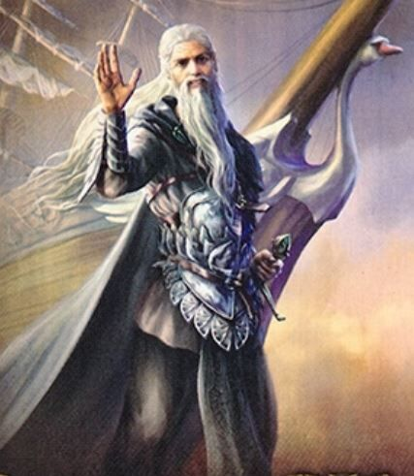
Long into the night Fin and I spoke. I shared all that had happened in Lothlorien and especially what happened a few nights ago at the Prancing Pony.
Fin shared that our grandfather and great uncle had safely made it to the undying lands.
Next, Fin shared about the first day he arrived at the Gray Havens. “On that day, Cirdan was not himself. He looked at me, Mel, and keep calling me Elwe. Elwe my old friend, I have missed you dearly, what are you doing here, Elwe!?” I assured Cirdan that I was not this person called Elwe. And that I was Fingilote from Lothlorien. “Yes of course he said, you just reminded me of someone from my past.” said Cirdan.
“Melody, do you know who Elwe might have been?” asked Fin. “I’m not sure Fin, but we should find out.” Melody replied.
Fin continued. “Once here, Mel, I just did not want to leave! It just felt like home. Cirdan seemed to truly enjoy having me around and has been teaching how to sail and how to make ships! He calls me his second-best apprentice, someone named Earendil, seemed to be pretty good.”
Again, out of nowhere Mel started speaking a poem: “a shape like a white boat, shining above him, that sailed west through the air, and as it dwindled in the distance it looked like a star of so great a brilliance that it cast a shadow of Cirdan upon the strand where he stood.”
“Wow! I am not sure where that came from Fin”. “It is ok, Melody, we will work through all this together, but we should try and sleep now. Glad you are here sis; I have missed you.” “ I’ve missed you too, my big eared brother! Goodnight, Fin.” “Goodnight, Melody.”
_____________________________________________________________________________________
Melody Gale Truesong - Half Elven - Bard : Fingilote Diors Northstar – High Elf – Warrior/Rogue
Unknow to Mel, and Fin … Earendil (father of Elrond and Elros) was once Cirdan’s apprentice. Cirdan and Earendil together built the ship Vingilótë.

Later, Eärendil along with his wife, Elwing (great aunt of Fin and Mel), sailed this glorious ship to Aman to seek pardon and assistance from the Valar. This vessel was said to be the fairest ever fashioned – it had white timbers of birchwood from Nimbrethil, oars of gold, sails of silver, and its prow was swan-shaped.

The Valar heard their plea for help and enchanted the ship to fly through the sky on its way to Middle-earth to wage war on Morgoth. Earendil wore on his brow the neckless holding the Simaril while piloting Vingilótë. Earendil, with the Simaril on this brow, would be seen as a star in the night sky. This star is still known today as “The Star of Earendil.”

The spelling of Earendil’s ship and Fin’s name. Vingilótë – Fingilótë, fate?

Cirdan’s Journal note: When I saw Fingilote and Melody coming towards me with their arms together, it may have been the odd light or the shadows on their faces, but my mind was taken back in time.
For in that moment, it was as if I was seeing, “Thingol and Melian” walking in middle earth again.”

Fingilote Diors Northstar – High Elf – Warrior/Rogue
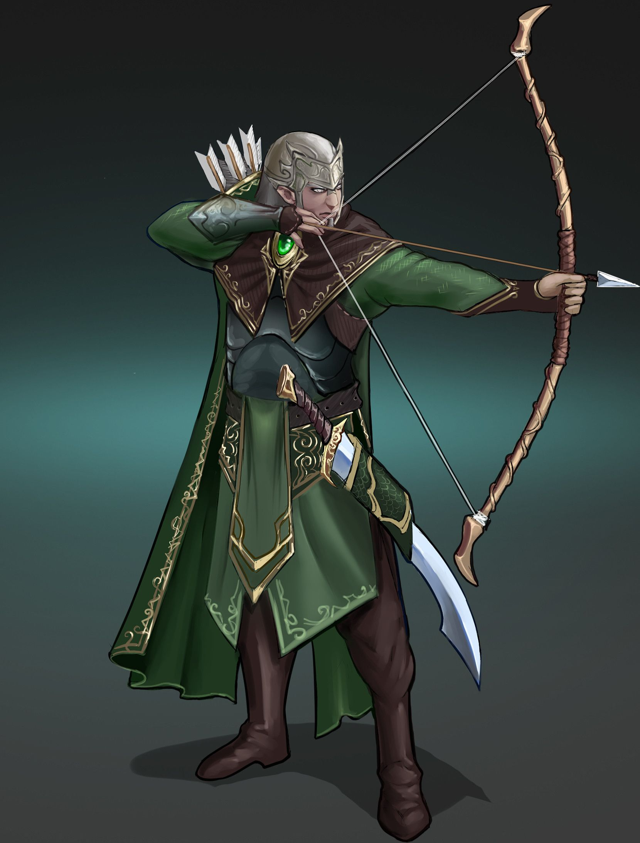
Melody Gale Truesong - Half Elven - Bard


